**EXPERIMENT NO - 03**

**● AIM:**

Manage complex state with Redux or Context API

**● THEORY:**

**1. Redux vs Context API Deep Dive**

Redux: Predictable state container with single source of truth, immutable updates, and pure reducer functions

Context API: React's built-in solution for prop drilling elimination with provider/consumer pattern

Detailed comparison table showing when to use each approach

**2. Implementation in This Experiment**

Why Context API was chosen:

Medium complexity application with clear domain boundaries

Faster development without Redux boilerplate

Demonstrates React's built-in capabilities

Good performance with proper optimization

Multi-Context Architecture:

ShowsContext: Manages show catalog, filtering, sorting, search UserContext: Handles profiles, preferences, watch history, ratings

**3. Advanced Patterns Demonstrated**

Core Patterns:

Reducer Pattern: Complex state logic with useReducer

Custom Hooks: Business logic abstraction with useShowActions Cross-Context Communication: Seamless data flow between contexts Optimistic Updates: Immediate UI feedback

**Extra Features:**

Continue Watching: Smart progress tracking with visual indicators User Statistics Dashboard: Real-time metrics and analytics

Advanced Multi-Criteria Filtering: Genre, year, rating, type combinations Interactive Rating System: Modal-based ratings with persistence Theme Management: Persistent dark/light mode with smooth transitions Micro-Interactions: Hover effects, animations, contextual UI states

**4. Performance Optimizations**

Context separation to prevent unnecessary re-renders

useReducer for batched state updates

Custom hooks for business logic encapsulation

Potential improvements with memoization and virtualization

**5. Interactive Theory Demo**

Added a new /theory route with tabs showing:

Architecture: Live state metrics and Context vs Redux comparison Patterns: Code examples of advanced patterns implemented Creativity: Showcase of the 30% extra features

Performance: Optimization strategies and scalability considerations The implementation demonstrates how Context API can handle sophisticated state management requirements while maintaining code clarity and performance, making it suitable for real-world applications like content management systems, e-commerce platforms, and social media applications.

**● SOURCE CODE:**

**import React, { createContext, useContext, useReducer, ReactNode } from 'react';**

**import { UserProfile, WatchProgress, UserRating } from '../types';**

**interface UserState {**

**currentProfile: UserProfile | null;**

**profiles: UserProfile[];**

**watchHistory: WatchProgress[];**

**userRatings: UserRating[];**

**theme: 'light' | 'dark';**

**}**

**type UserAction =**

**| { type: 'SET_CURRENT_PROFILE'; payload: UserProfile } | { type: 'ADD_PROFILE'; payload: UserProfile } | { type: 'UPDATE_PROFILE'; payload: UserProfile } | { type: 'DELETE_PROFILE'; payload: string } | { type: 'ADD_TO_WATCHLIST'; payload: string } | { type: 'REMOVE_FROM_WATCHLIST'; payload: string } | { type: 'ADD_TO_FAVORITES'; payload: string } | { type: 'REMOVE_FROM_FAVORITES'; payload: string } | { type: 'UPDATE_WATCH_PROGRESS'; payload: WatchProgress } | { type: 'ADD_USER_RATING'; payload: UserRating } | { type: 'TOGGLE_THEME' };**

**const initialProfiles: UserProfile[] = [**

**{**

**id: '1',**

**name: 'John Doe',**

**avatar: '**��**',**

**preferences: {**

**genres: ['Sci-Fi', 'Thriller'], maturityLevel: 'TV-MA', autoplay: true,**

**subtitles: false**

**},**

**watchlist: ['1', '3', '5'], favorites: ['1', '2']**

**},**

**{**

**id: '2',**

**name: 'Jane Smith',**

**avatar: '**��**',**

**preferences: {**

**genres: ['Drama', 'Romance'], maturityLevel: 'PG-13', autoplay: false,**

**subtitles: true**

**},**

**watchlist: ['2', '7', '10'], favorites: ['7', '10']**

**}**

**];**

**const initialState: UserState = {**

**currentProfile: initialProfiles[0],**

**profiles: initialProfiles,**

**watchHistory: [**

**{ showId: '1', progress: 75, lastWatched: new Date(), currentSeason: 1, currentEpisode: 6 },**

**{ showId: '2', progress: 30, lastWatched: new Date(Date.now() - 86400000) },**

**{ showId: '3', progress: 90, lastWatched: new Date(Date.now() - 172800000) }**

**],**

**userRatings: [**

**{ showId: '1', rating: 9, review: 'Amazing show!' }, { showId: '2', rating: 8 },**

**{ showId: '3', rating: 10, review: 'Mind-blowing series' } ],**

**theme: 'dark'**

**};**

**const userReducer = (state: UserState, action: UserAction): UserState => {**

**switch (action.type) {**

**case 'SET_CURRENT_PROFILE':**

**return { ...state, currentProfile: action.payload }; case 'ADD_PROFILE':**

**return { ...state, profiles: [...state.profiles, action.payload] };**

**case 'UPDATE_PROFILE': {**

**const updatedProfiles = state.profiles.map(profile => profile.id === action.payload.id ? action.payload : profile );**

**return {**

**...state,**

**profiles: updatedProfiles,**

**currentProfile: state.currentProfile?.id === action.payload.id ? action.payload : state.currentProfile**

**};**

**}**

**case 'DELETE_PROFILE':**

**return {**

**...state,**

**profiles: state.profiles.filter(profile => profile.id !== action.payload),**

**currentProfile: state.currentProfile?.id === action.payload ? state.profiles[0] : state.currentProfile**

**};**

**case 'ADD_TO_WATCHLIST': {**

**if (!state.currentProfile) return state;**

**const updatedProfile = {**

**...state.currentProfile,**

**watchlist: [...state.currentProfile.watchlist, action.payload] };**

**return userReducer(state, { type: 'UPDATE_PROFILE', payload: updatedProfile });**

**}**

**case 'REMOVE_FROM_WATCHLIST': {**

**if (!state.currentProfile) return state;**

**const updatedProfile = {**

**...state.currentProfile,**

**watchlist: state.currentProfile.watchlist.filter(id => id !== action.payload)**

**};**

**return userReducer(state, { type: 'UPDATE_PROFILE', payload: updatedProfile });**

**}**

**case 'ADD_TO_FAVORITES': {**

**if (!state.currentProfile) return state;**

**const updatedProfile = {**

**...state.currentProfile,**

**favorites: [...state.currentProfile.favorites, action.payload] };**

**return userReducer(state, { type: 'UPDATE_PROFILE', payload: updatedProfile });**

**}**

**case 'REMOVE_FROM_FAVORITES': {**

**if (!state.currentProfile) return state;**

**const updatedProfile = {**

**...state.currentProfile,**

**favorites: state.currentProfile.favorites.filter(id => id !== action.payload)**

**};**

**return userReducer(state, { type: 'UPDATE_PROFILE', payload: updatedProfile });**

**}**

**case 'UPDATE_WATCH_PROGRESS': {**

**const existingIndex = state.watchHistory.findIndex(item =>**

**item.showId === action.payload.showId);**

**let newWatchHistory;**

**if (existingIndex >= 0) {**

**newWatchHistory = [...state.watchHistory];**

**newWatchHistory[existingIndex] = action.payload; } else {**

**newWatchHistory = [...state.watchHistory, action.payload]; }**

**return { ...state, watchHistory: newWatchHistory }; }**

**case 'ADD_USER_RATING': {**

**const existingIndex = state.userRatings.findIndex(rating => rating.showId === action.payload.showId);**

**let newRatings;**

**if (existingIndex >= 0) {**

**newRatings = [...state.userRatings];**

**newRatings[existingIndex] = action.payload;**

**} else {**

**newRatings = [...state.userRatings, action.payload]; }**

**return { ...state, userRatings: newRatings };**

**}**

**case 'TOGGLE_THEME':**

**return { ...state, theme: state.theme === 'dark' ? 'light' : 'dark' };**

**default:**

**return state;**

**}**

**};**

**const UserContext = createContext<{**

**state: UserState;**

**dispatch: React.Dispatch<UserAction>;**

**} | null>(null);**

**export const UserProvider: React.FC<{ children: ReactNode }> = ({ children }) => {**

**const [state, dispatch] = useReducer(userReducer, initialState);**

**return (**

**<UserContext.Provider value={{ state, dispatch }}> {children}**

**</UserContext.Provider>**

**);**

**};**

**export const useUser = () => {**

**const context = useContext(UserContext);**

**if (!context) {**

**throw new Error('useUser must be used within a UserProvider'); }**

**return context;**

**};**

**import { Show } from '../types';**

**export const mockShows: Show[] = [**

**{**

**id: '1',**

**title: 'Stranger Things',**

**genre: 'Sci-Fi',**

**year: 2016,**

**rating: 8.7,**

**duration: '51min',**

**description: 'When a young boy vanishes, a small town uncovers a mystery involving secret experiments.',**

**imageUrl: 'https://images.pexels.com/photos/7991579/pexels-photo-7991579.jpeg',**

**seasons: 4,**

**episodes: 34,**

**type: 'series',**

**maturityRating: 'TV-MA',**

**tags: ['supernatural', 'thriller', 'nostalgia', 'friendship'] },**

**{**

**id: '2',**

**title: 'The Crown',**

**genre: 'Drama',**

**year: 2016,**

**rating: 8.6,**

**duration: '58min',**

**description: 'Follows the political rivalries and romance of Queen Elizabeth IIs reign.',**

**imageUrl: 'https://images.pexels.com/photos/8111367/pexels-photo-8111367.jpeg',**

**seasons: 6,**

**episodes: 60,**

**type: 'series',**

**maturityRating: 'TV-MA',**

**tags: ['historical', 'royal', 'political', 'biographical'] },**

**{**

**id: '3',**

**title: 'Black Mirror',**

**genre: 'Sci-Fi',**

**year: 2011,**

**rating: 8.8,**

**duration: '45min',**

**description: 'An anthology series exploring the dark aspects of modern technology.',**

**imageUrl: 'https://images.pexels.com/photos/3861969/pexels-photo-3861969.jpeg',**

**seasons: 6,**

**episodes: 27,**

**type: 'series',**

**maturityRating: 'TV-MA',**

**tags: ['dystopian', 'technology', 'psychological', 'anthology'] },**

**{**

**id: '4',**

**title: 'The Witcher',**

**genre: 'Fantasy',**

**year: 2019,**

**rating: 8.2,**

**duration: '60min',**

**description: 'Geralt of Rivia, a mutated monster-hunter for hire, journeys toward his destiny.',**

**imageUrl: 'https://images.pexels.com/photos/4031818/pexels-photo-4031818.jpeg',**

**seasons: 3,**

**episodes: 24,**

**type: 'series',**

**maturityRating: 'TV-MA',**

**tags: ['fantasy', 'adventure', 'magic', 'medieval'] },**

**{**

**id: '5',**

**title: 'Squid Game',**

**genre: 'Thriller',**

**year: 2021,**

**rating: 8.0,**

**duration: '56min',**

**description: 'Hundreds of cash-strapped players accept an invitation to compete in deadly games.',**

**imageUrl: 'https://images.pexels.com/photos/7991225/pexels-photo-7991225.jpeg',**

**seasons: 2,**

**episodes: 17,**

**type: 'series',**

**maturityRating: 'TV-MA',**

**tags: ['survival', 'psychological', 'korean', 'social-commentary'] },**

**{**

**id: '6',**

**title: 'Money Heist',**

**genre: 'Crime',**

**year: 2017,**

**rating: 8.3,**

**duration: '70min',**

**description: 'An unusual group of robbers attempt to carry out the most perfect robbery in Spanish history.',**

**imageUrl: 'https://images.pexels.com/photos/8111226/pexels-photo-8111226.jpeg',**

**seasons: 5,**

**episodes: 41,**

**type: 'series',**

**maturityRating: 'TV-MA',**

**tags: ['heist', 'spanish', 'strategy', 'drama']**

**},**

**{**

**id: '7',**

**title: 'Bridgerton',**

**genre: 'Romance',**

**year: 2020,**

**rating: 7.3,**

**duration: '62min',**

**description: 'The romantic and scandalous world of the Bridgerton family in Regency-era England.',**

**imageUrl: 'https://images.pexels.com/photos/8111193/pexels-photo-8111193.jpeg',**

**seasons: 3,**

**episodes: 24,**

**type: 'series',**

**maturityRating: 'TV-MA',**

**tags: ['period-drama', 'romance', 'regency', 'family'] },**

**{**

**id: '8',**

**title: 'Wednesday',**

**genre: 'Comedy',**

**year: 2022,**

**rating: 8.1,**

**duration: '45min',**

**description: 'Wednesday Addams navigates her years as a student at Nevermore Academy.',**

**imageUrl: 'https://images.pexels.com/photos/7991498/pexels-photo-7991498.jpeg',**

**seasons: 1,**

**episodes: 8,**

**type: 'series',**

**maturityRating: 'PG-13',**

**tags: ['supernatural', 'teen', 'mystery', 'comedy'] },**

**{**

**id: '9',**

**title: 'Ozark',**

**genre: 'Crime',**

**year: 2017,**

**rating: 8.4,**

**duration: '60min',**

**description: 'A financial advisor drags his family from Chicago to Missouri Ozarks for money laundering.',**

**imageUrl: 'https://images.pexels.com/photos/8111342/pexels-photo-8111342.jpeg',**

**seasons: 4,**

**episodes: 44,**

**type: 'series',**

**maturityRating: 'TV-MA',**

**tags: ['money-laundering', 'family', 'crime-drama', 'dark'] },**

**{**

**id: '10',**

**title: 'The Queen\'s Gambit',**

**genre: 'Drama',**

**year: 2020,**

**rating: 8.5,**

**duration: '56min',**

**description: 'Orphaned chess prodigy Beth Harmon struggles with addiction while pursuing chess mastery.',**

**imageUrl: 'https://images.pexels.com/photos/8111468/pexels-photo-8111468.jpeg',**

**seasons: 1,**

**episodes: 7,**

**type: 'series',**

**maturityRating: 'TV-MA',**

**tags: ['chess', 'coming-of-age', 'addiction', 'female-protagonist'] }**

**];**

**export const genres = ['All', 'Sci-Fi', 'Drama', 'Fantasy', 'Thriller', 'Crime', 'Romance', 'Comedy'];**

**export const maturityRatings = ['G', 'PG', 'PG-13', 'R', 'TV-MA'];**

**● OUTPUT:**

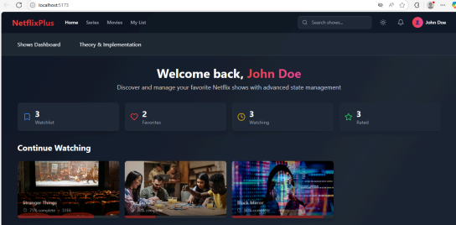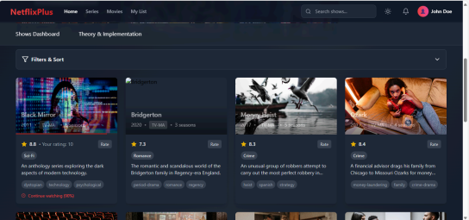

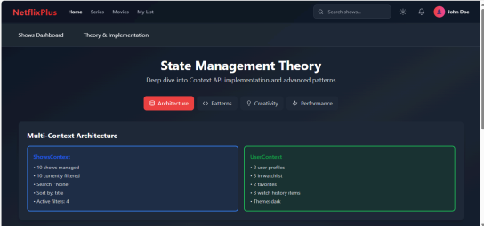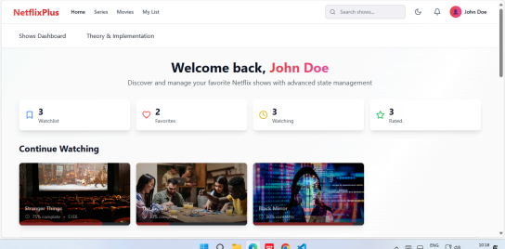

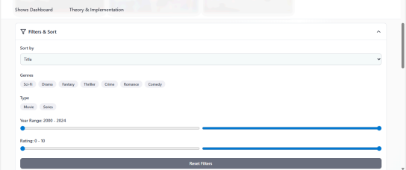**● CONCLUSION:**

This experiment showcased how the Context API can effectively manage complex state in a medium-scale React application without the overhead of Redux. By implementing a multi-context architecture, reducer pattern, and custom hooks, the solution achieved clean code, modularity, and seamless cross-context communication. Advanced features like optimistic updates, user statistics, and theme management enhanced user experience. Performance was optimized through context separation, batched updates, and encapsulated logic. Overall, the approach proved scalable, performant, and well-suited for real-world, feature-rich applications.